Week1:
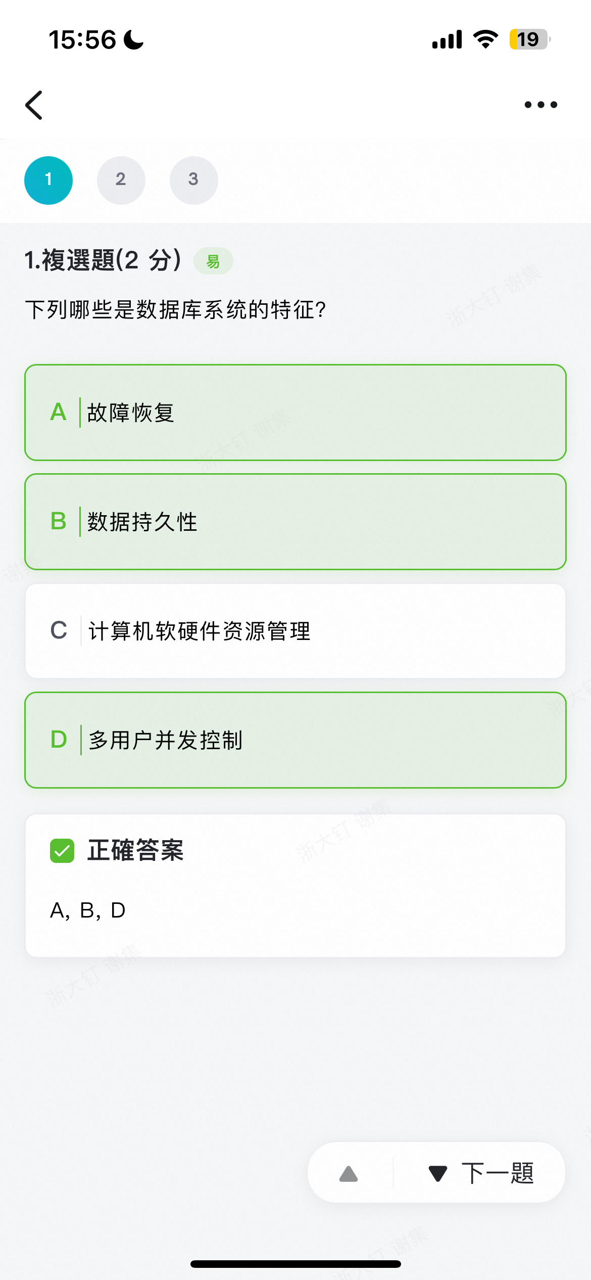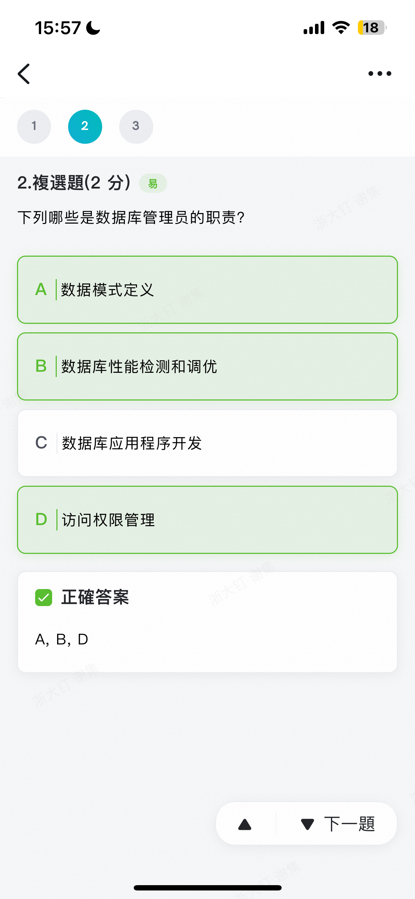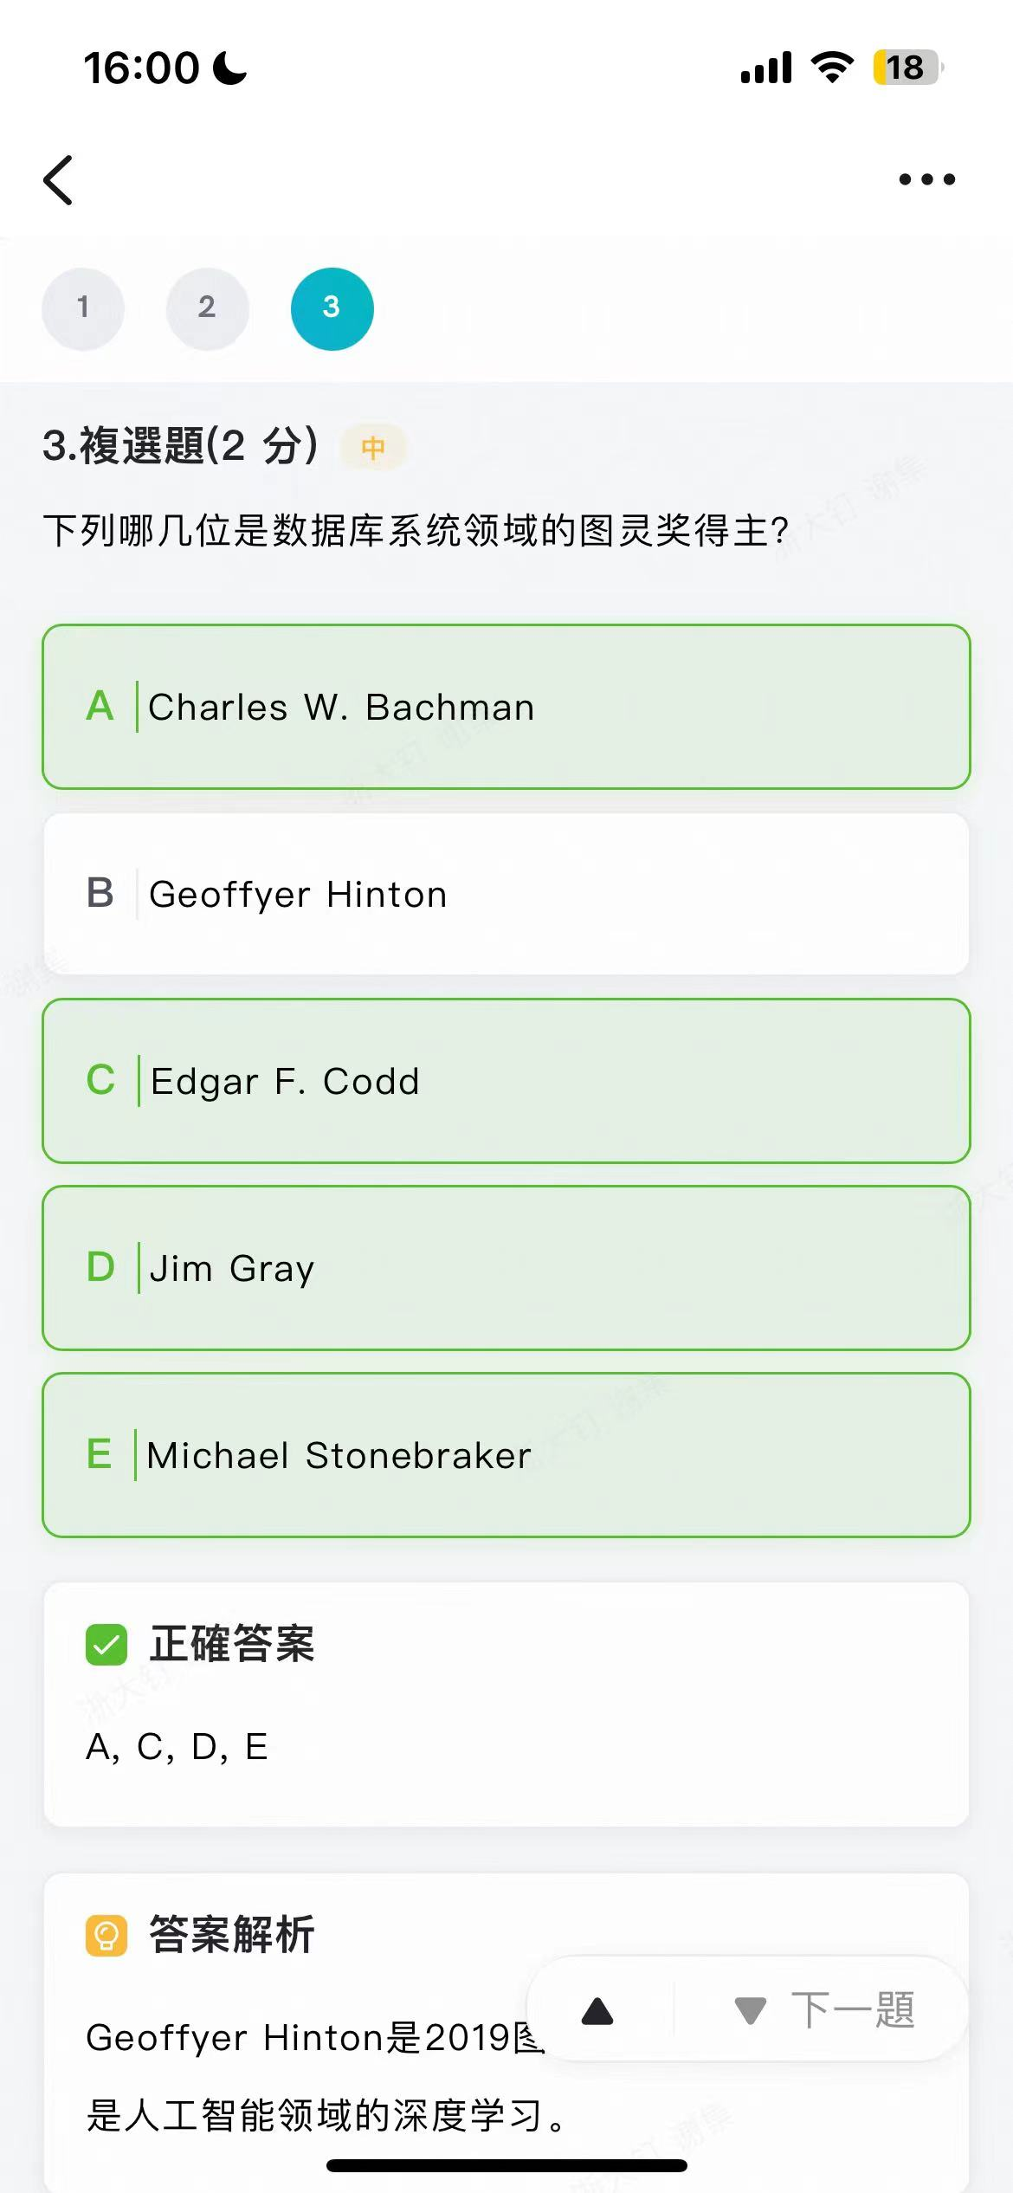

很难评价只能说，第一章的看个乐好了（应该不会考的）。

Week2：

- 下列哪几个操作不是关系代数的基本操作？
- Set union
- Set intersection
- Set difference
- Cartesian product
- Division operator

BE。6个基本操作是select、project、union、difference、cartesian product、rename。其他都可以推出来。

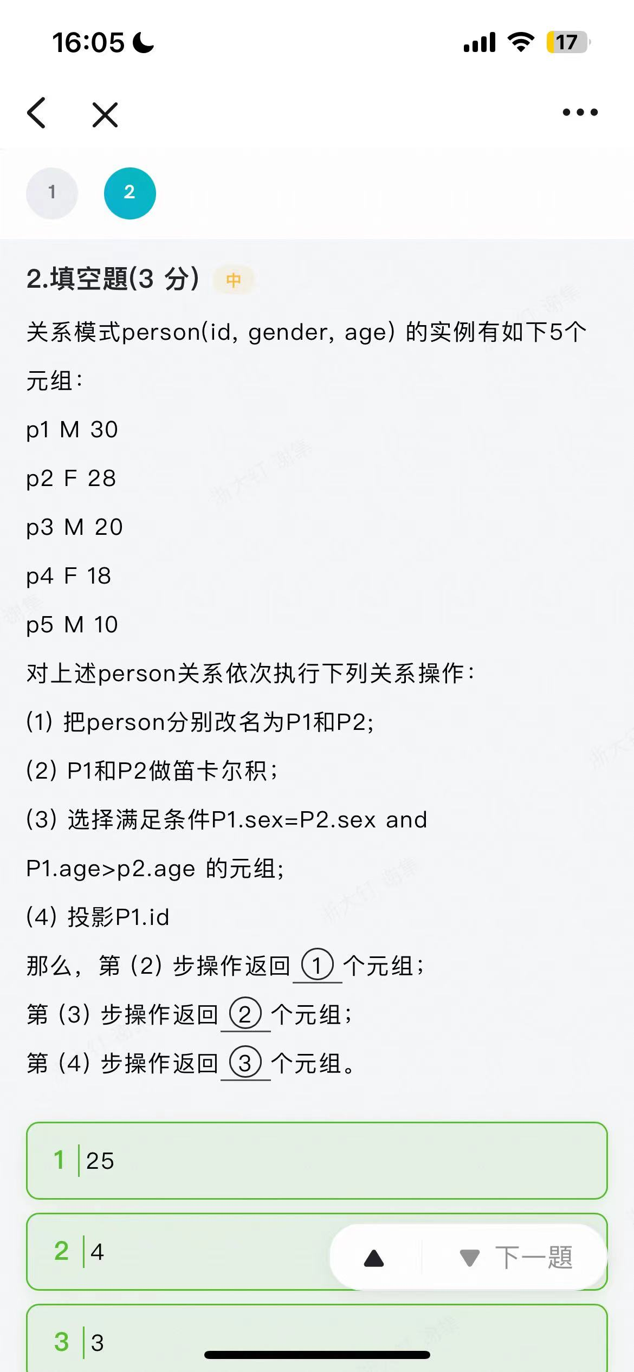

很基础，不解释。

Week3：
The table person is defined as following:
create table person( id char(3),
pid char(3),
primary key(id),
foreign key (pid)
references person on delete cascade on update cascade);
An instance of the table <person> is as following
id pid
001
002 001
003 001
004 002
005 004
006 003
007 006

- The result of the following statement is: __________
select count(*) from person where pid is not NULL group by pid having count(*)>1;
- After running the following statement:
delete * from person where id='001';
the result of the following statement is:___________
select count(*) from person;

2 0。第一问按照pid分，只有pid=001满足条件，然后里面有2个。其实本来得到的应该是一张表，但是表里只有一个数据。
第二个经典坑题，删了 001，多米诺骨牌一样，全删掉了。

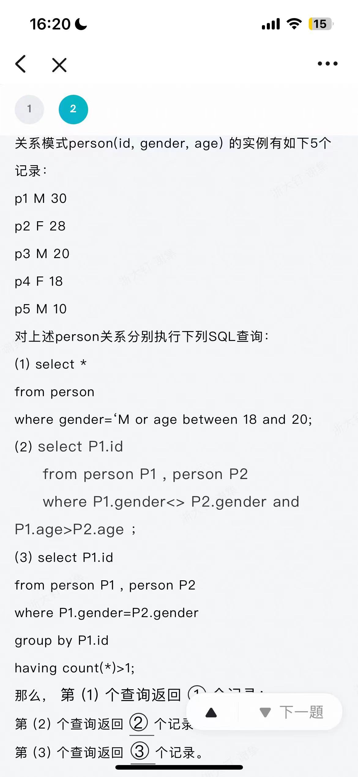
题目改了，第三小问是having count(*)>2.
4 6 3. 不然是 4 6 5.
Week4:
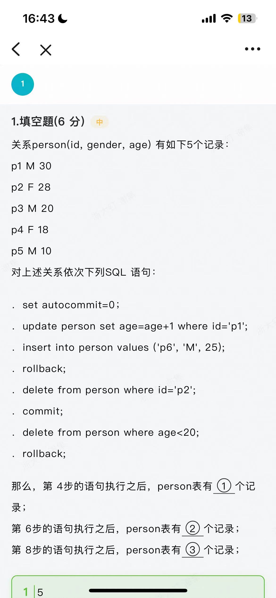
5 4 4.
Week5:
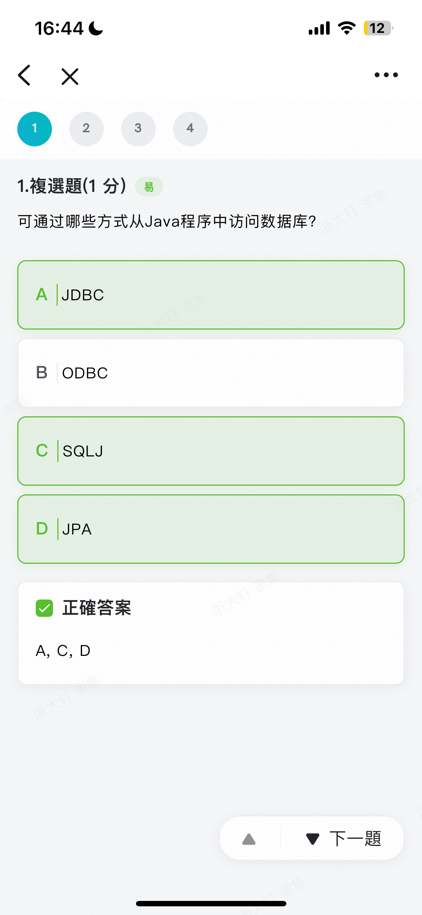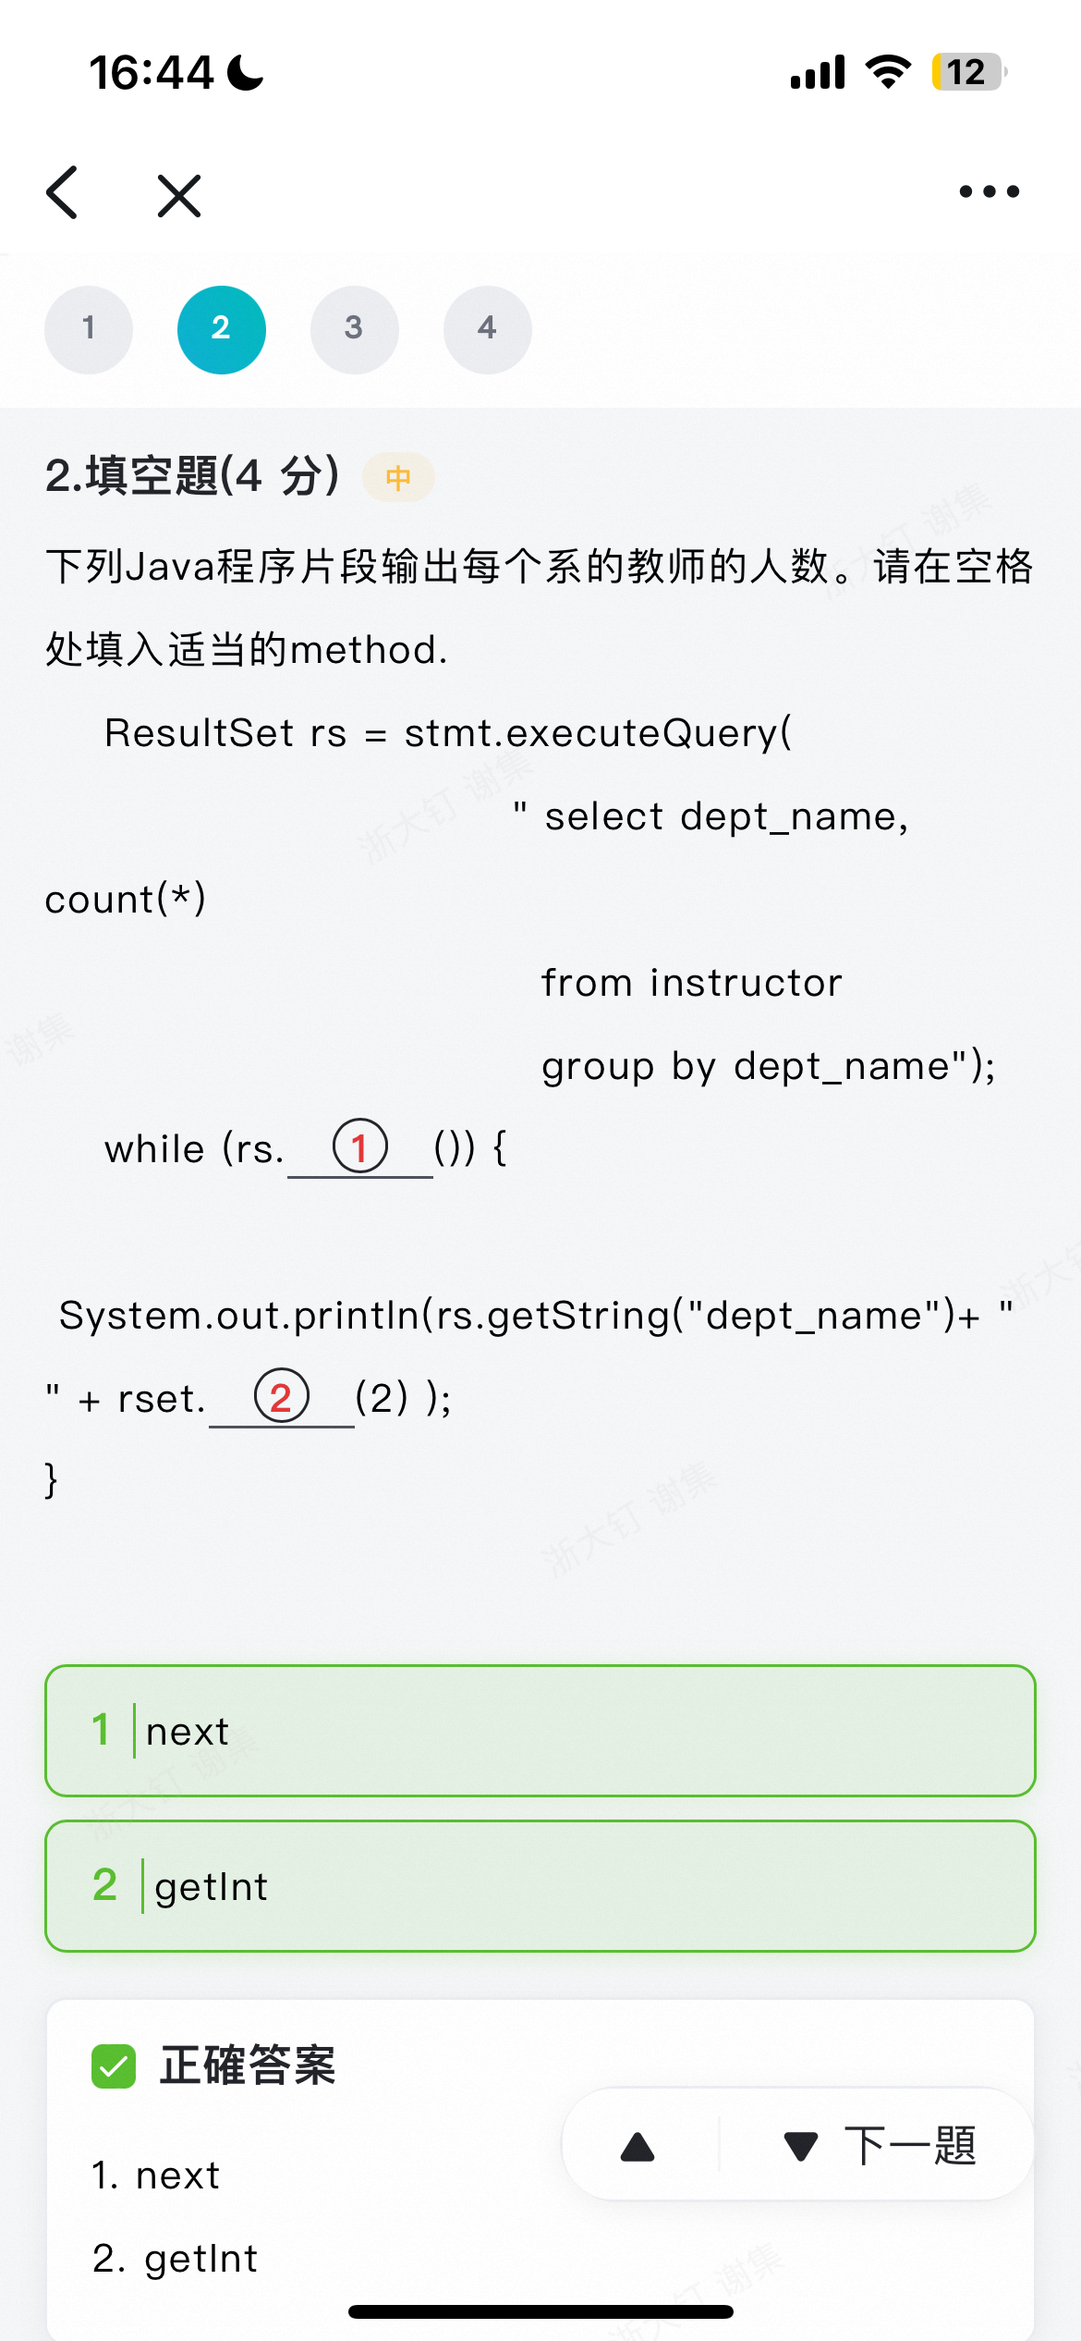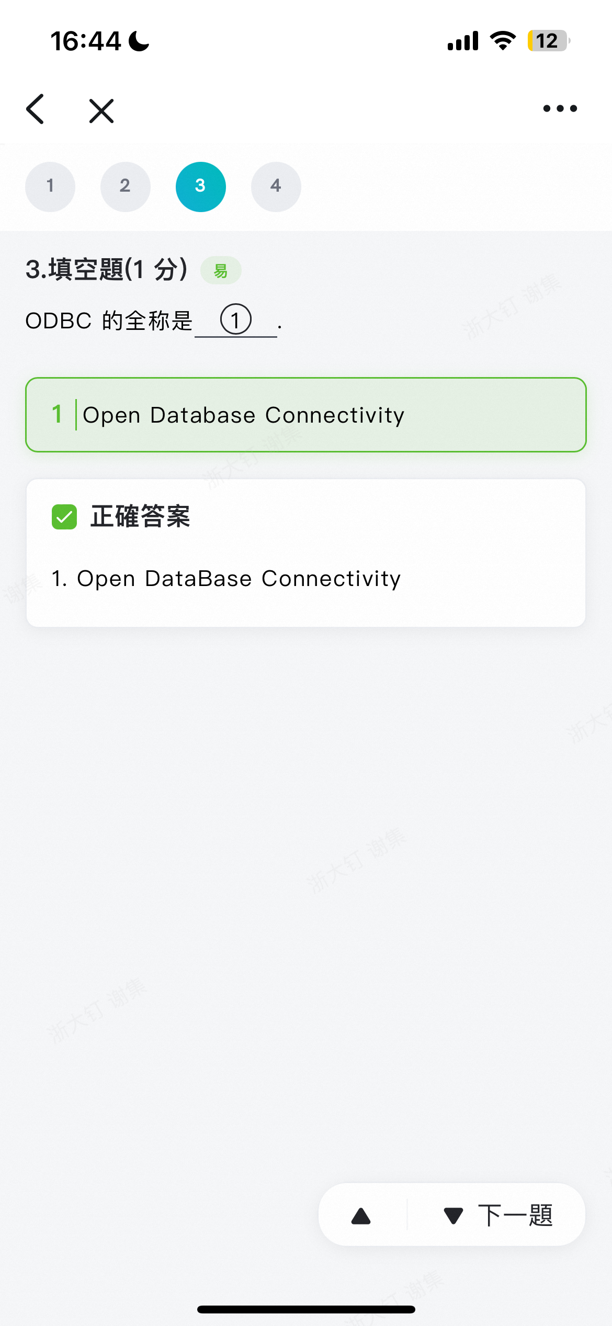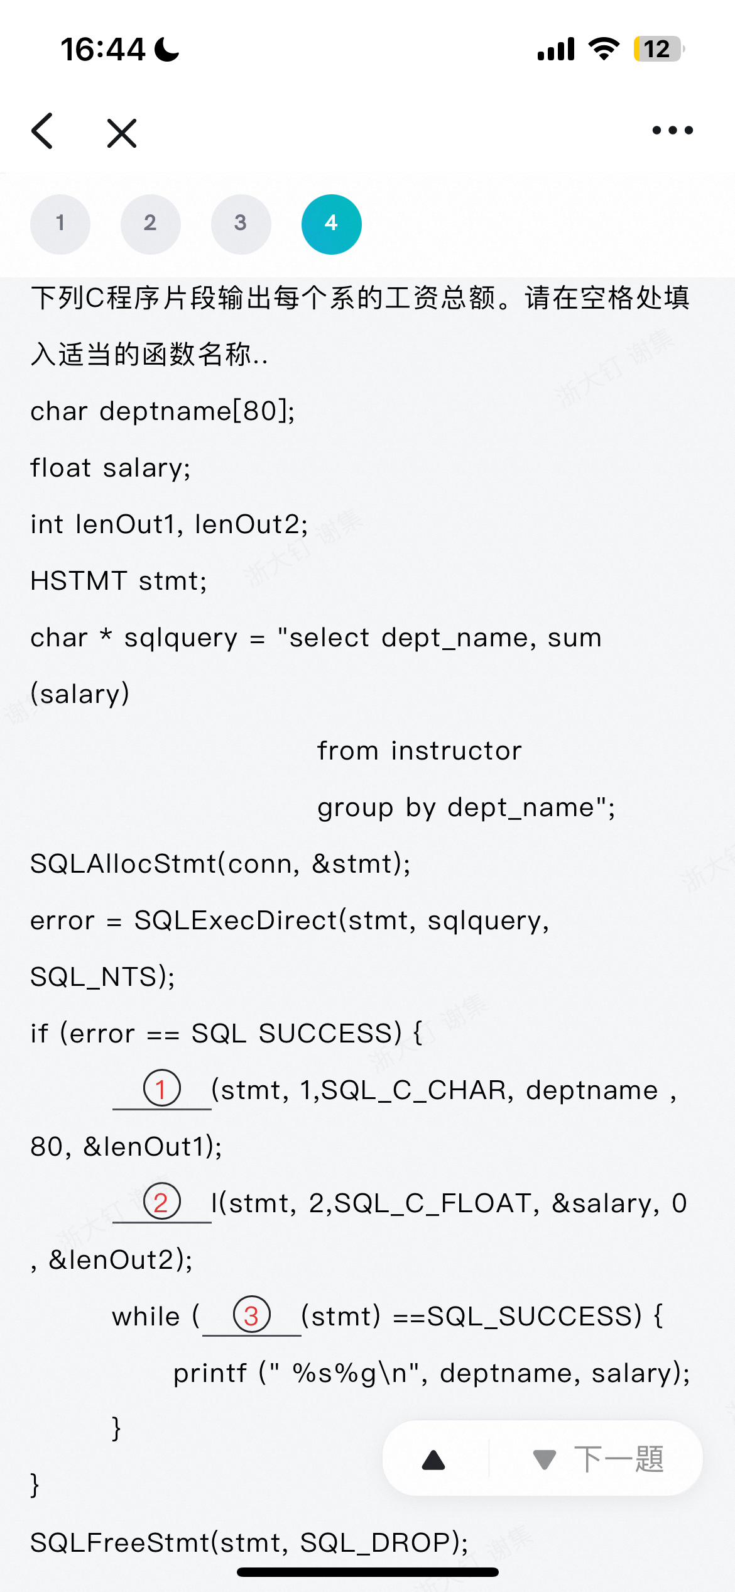
Cheeting sheet，请…
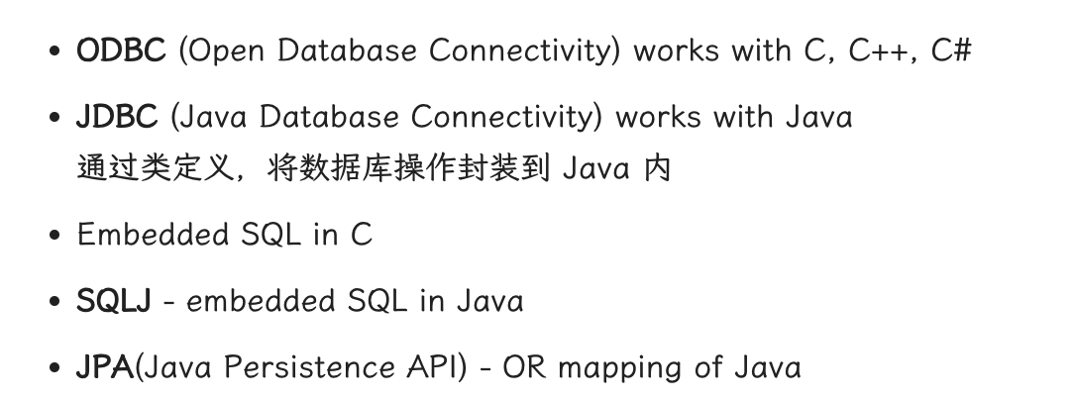
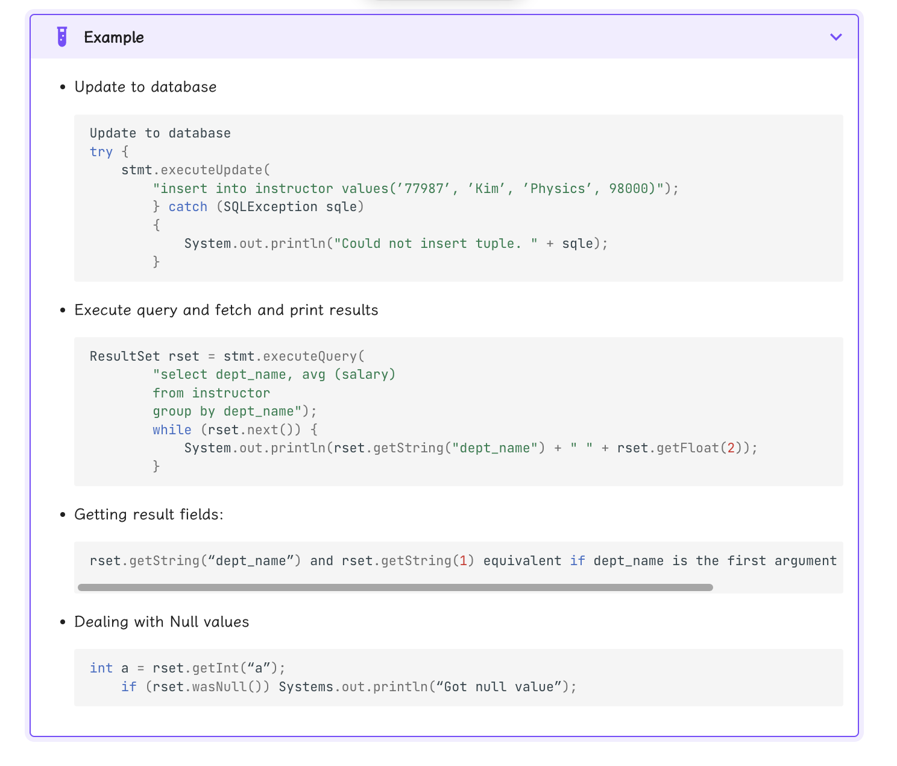
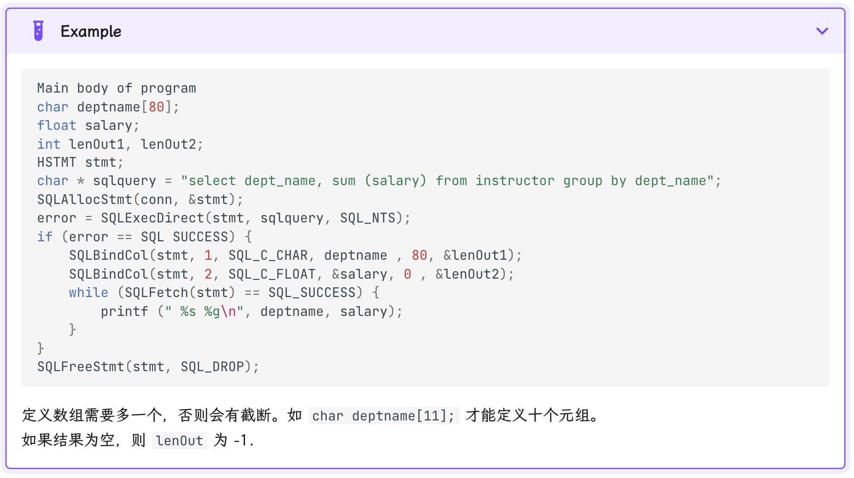
Week6:
